
Building a
Customer 360 Analytics Framework

E Commerce Intelligent System – Project Report

MAY 2026

Authored by: Atanu Dutta Gupta

End-to-End E-commerce Intelligence System: Building a customer 360 Analytics Framework

Business Problem Statement
In modern e-commerce ecosystems, data is generated across multiple independent systems such as customer management, order processing, payments, product catalogs, seller networks, and customer feedback platforms. These datasets are typically fragmented and stored in separate tables, making it difficult to extract unified insights.
The objective of this project is to simulate a real-world data analytics scenario where you are required to:
- Integrate multiple data sources into a unified analytical dataset
- Construct a customer 360 View
- Analyze customer behavior, revenue patterns, and operational performance
- Identify key drivers of business growth and customer satisfaction
- Generate actionable, data-driven business recommendations
This project reflects how data analysts and data scientists work in real organizations, where raw data must be transformed into meaningful insights before applying machine learning models.

Dataset Description

Dataset Description

To get started right away, just tap any placeholder text (such as this) and start typing to replace it with your own.

“Find even more easy-to-use tools on the Insert tab, such as to add a hyperlink or insert a comment”
To get started right away, just tap any placeholder text (such as this) and start typing to replace it with your own.

Want to insert a picture from your files or add a shape, text box, or table? You got it! On the Insert tab of the ribbon, just tap the option you need.

Entity Relationship Diagram:
This ERD shows a simple ecommerce system where everything revolves around orders. Customers place orders, and each order can have multiple products using the order_item table. Payments and reviews are stored separately to track transactions and feedback properly. Overall, it is a clean and well-organized design that avoids data duplication.

It is a snowflake schema because some dimension tables (like products → category_translation and customers/sellers → location) are further normalized into multiple related tables instead of being kept as single flat tables like in a star schema.

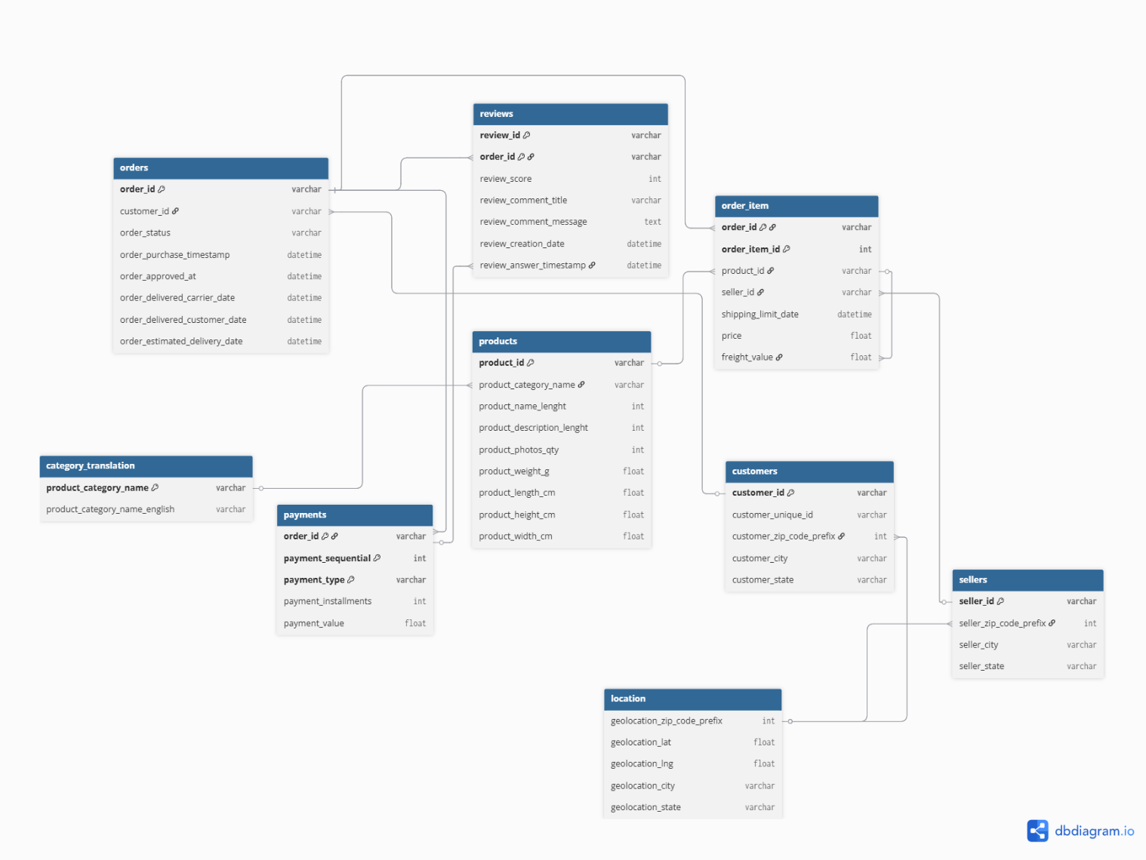

Methodology

Subtitle Text Here

To get started right away, just tap any placeholder text (such as this) and start typing to replace it with your own.

Want to insert a picture from your files or add a shape, text box, or table? You got it! On the Insert tab of the ribbon, just tap the option you need.
“Find even more easy-to-use tools on the Insert tab, such as to add a hyperlink or insert a comment”
To get started right away, just tap any placeholder text (such as this) and start typing to replace it with your own.

Want to insert a picture from your files or add a shape, text box, or table? You got it! On the Insert tab of the ribbon, just tap the option you need.

Key Findings

Subtitle Text Here

To get started right away, just tap any placeholder text (such as this) and start typing to replace it with your own.

Want to insert a picture from your files or add a shape, text box, or table? You got it! On the Insert tab of the ribbon, just tap the option you need.
“Find even more easy-to-use tools on the Insert tab, such as to add a hyperlink or insert a comment”
To get started right away, just tap any placeholder text (such as this) and start typing to replace it with your own.

Want to insert a picture from your files or add a shape, text box, or table? You got it! On the Insert tab of the ribbon, just tap the option you need.

Business Insights

Subtitle Text Here

To get started right away, just tap any placeholder text (such as this) and start typing to replace it with your own.

Want to insert a picture from your files or add a shape, text box, or table? You got it! On the Insert tab of the ribbon, just tap the option you need.
“Find even more easy-to-use tools on the Insert tab, such as to add a hyperlink or insert a comment”
To get started right away, just tap any placeholder text (such as this) and start typing to replace it with your own.

Want to insert a picture from your files or add a shape, text box, or table? You got it! On the Insert tab of the ribbon, just tap the option you need.

Visuals:

Sales Trend:
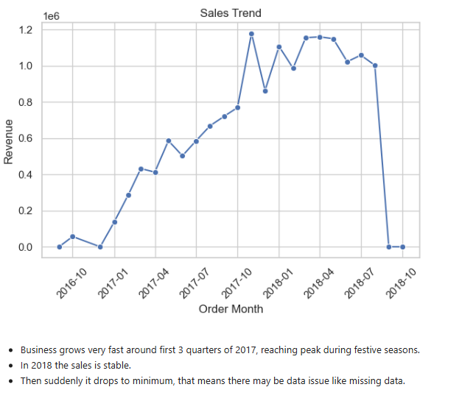
Category Performance:
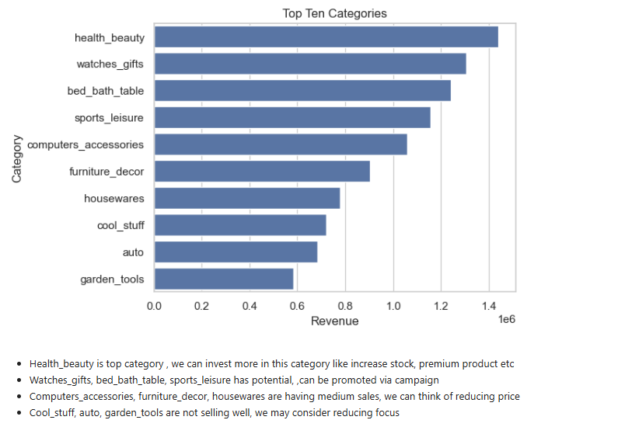
Category Performance:
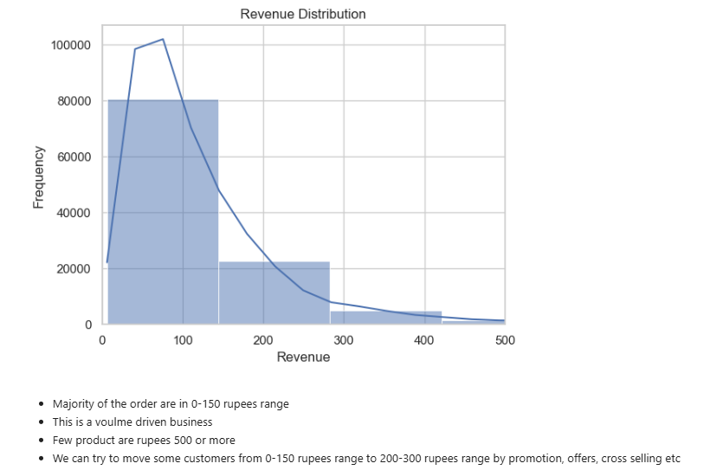

Outlier Detection:
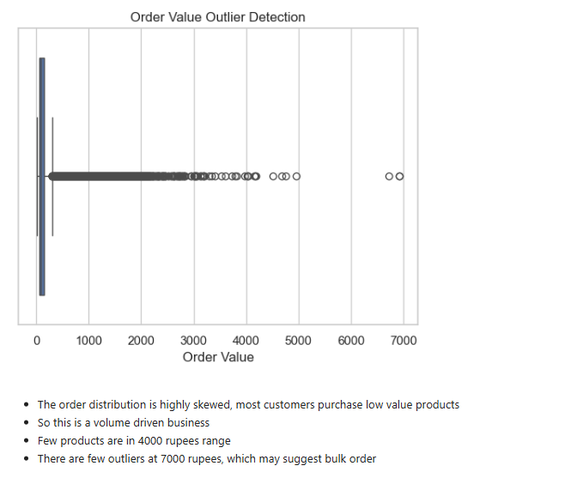

Heatmap for Correlation Analysis: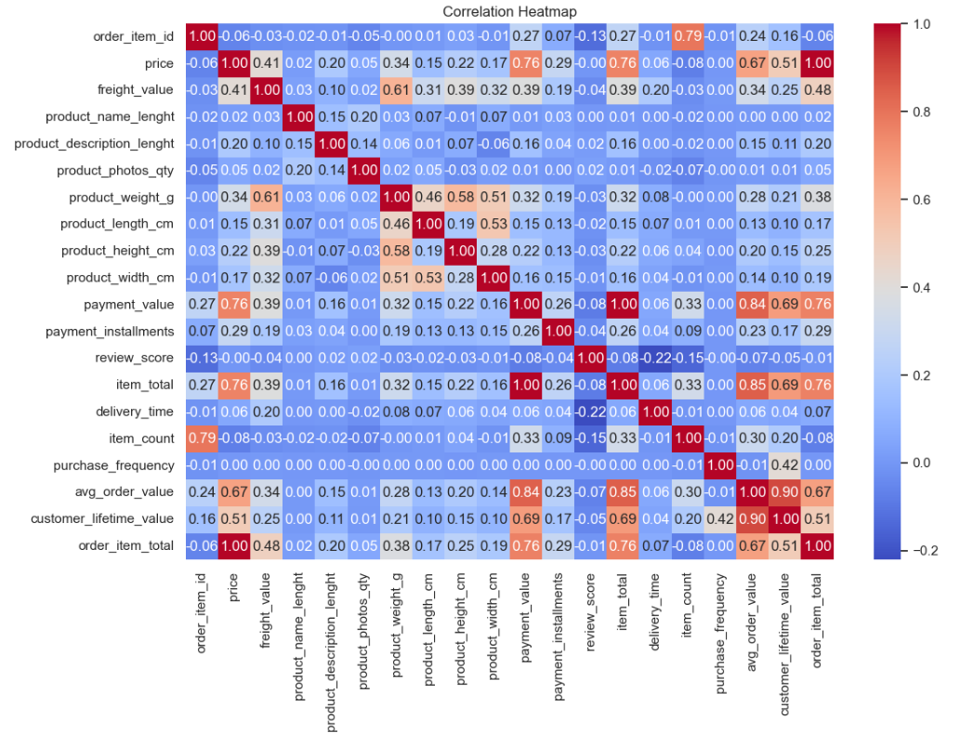

Recommendations

Subtitle Text Here

To get started right away, just tap any placeholder text (such as this) and start typing to replace it with your own.

Want to insert a picture from your files or add a shape, text box, or table? You got it! On the Insert tab of the ribbon, just tap the option you need.
“Find even more easy-to-use tools on the Insert tab, such as to add a hyperlink or insert a comment”

